Go to:

https://apisecurity.io/encyclopedia/content/oasv2/datavalidation/datavalidation

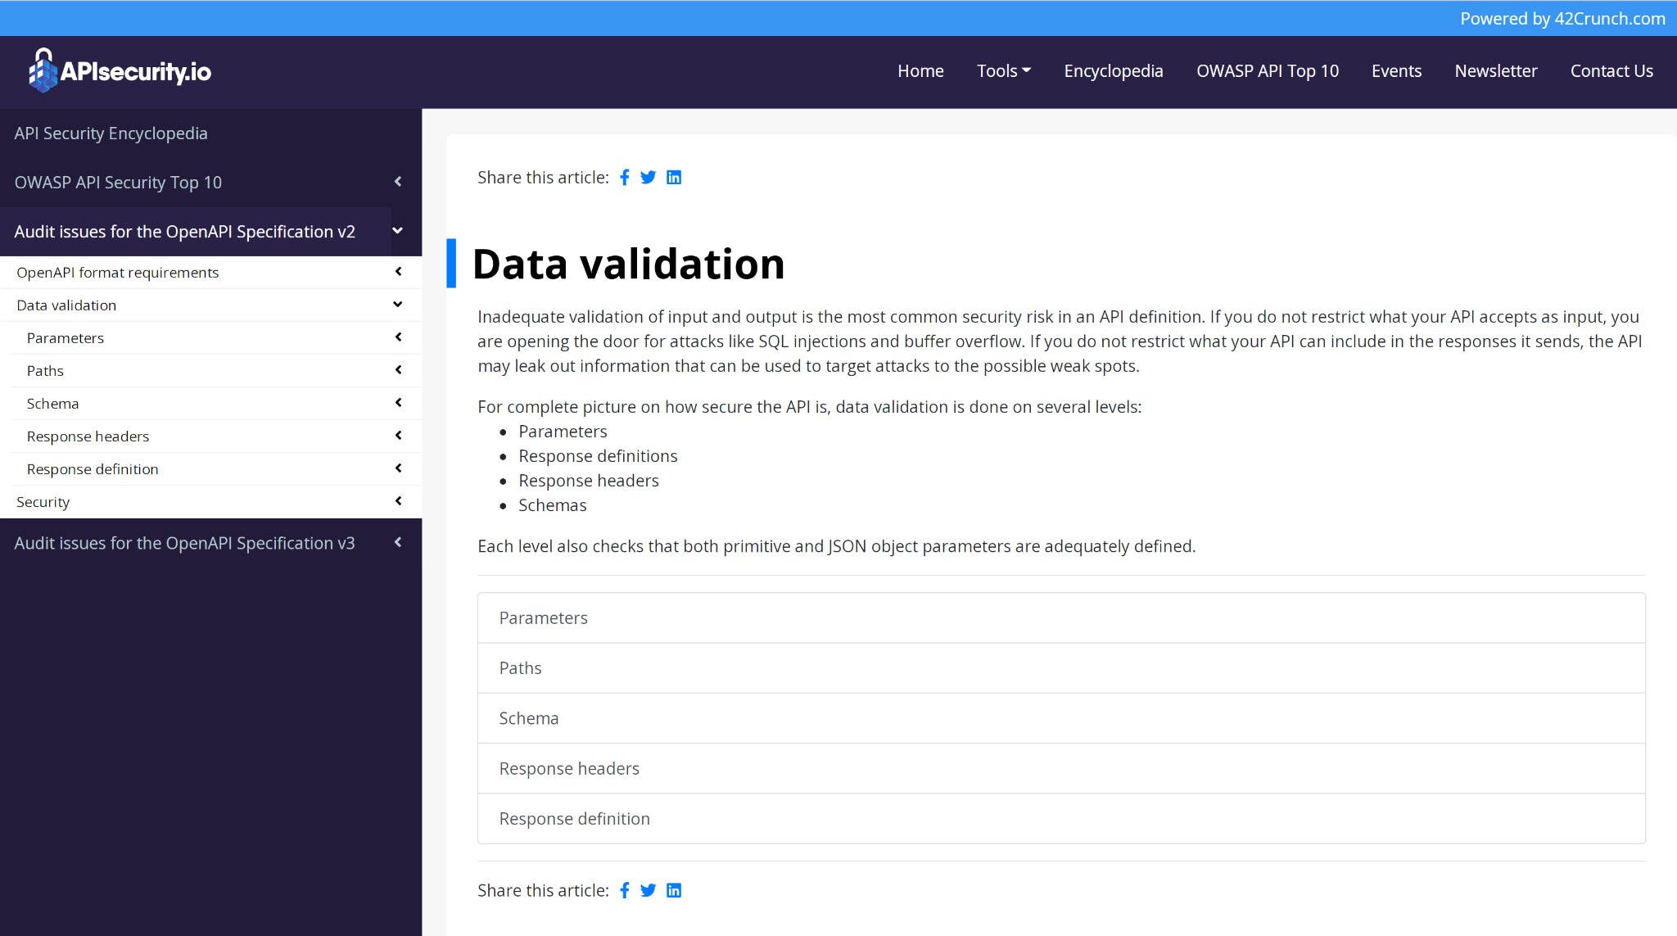

https://apisecurity.io/encyclopedia/content/owasp/owasp-api-security-top-10